**Attachment 1**

**Instructions loan repayment in MFC “ABN” via the “Elcart Mobile” application**

**Step 2**

Choose “ABN loan rpeayment”

**Step 1**

Choose the “Banking services” in “Elcart Mobile” application

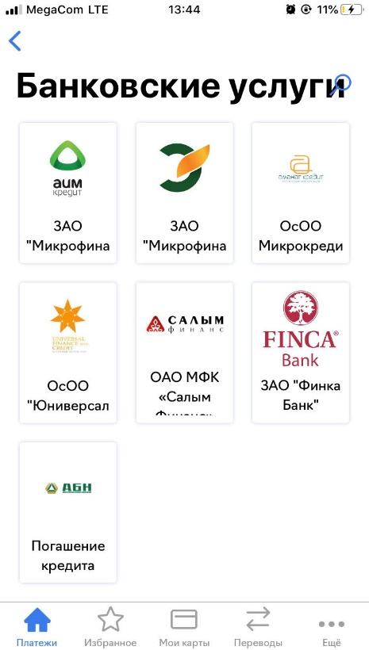

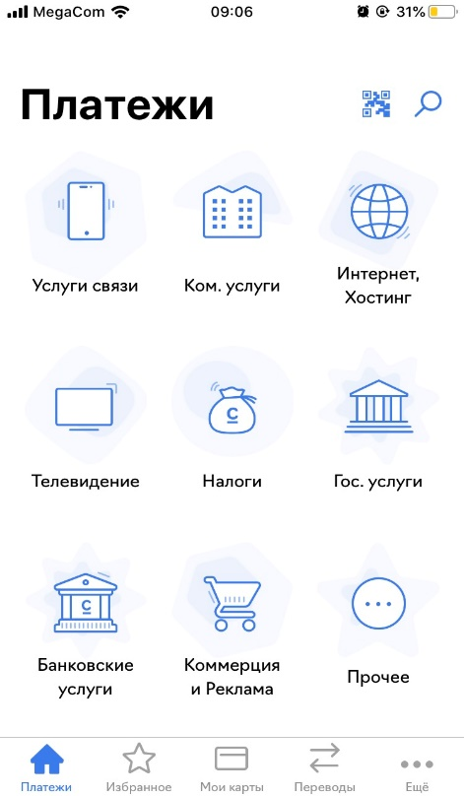

**Step 3**

Inter your account and an amount

